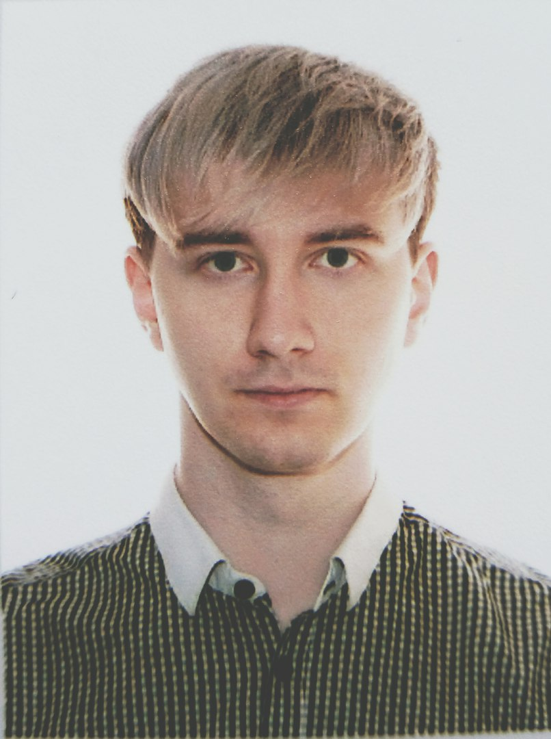
Maksym Matsydulskas
Middle Front-end developer

Details
Dnipro, Ukraine
+380669723993
slipmaks@gmail.com

Date of birth
09.09.1994

Links
github
resume (web verion)

Skills:
JavaScript, TypeScript, Vue.js 3, HTML5, CSS3 (Sass, Tailwind, Vuetify 3, Bootstrap), Nuxt.js 3, Axios, Linux / Windows, GIT, Figma, PWA, Service Workers

Languages
English (Intermediate), Ukrainian (native), Russian (fluent)

Hobbies
Writing code, Technology, Sport, Music/Playing guitar

Education

Master's Degree in Computer Science, University of Customs and Finance, Dnipro
September 2012 - 2017

Profile
Hi there! I'm Maksym and I am a multi-skilled, self-motivated Front-end Developer with 2.5+ years enterprise development experience.
I'm one of two front-end developers who made OneVOIPlanet admin cabinet, and I created by myself a site for University Custom and Finance of Ukraine.
My main technology stack ( but it's increase through time, i'm trying learn and use modern fresh technologies ) is Vue.js 3, JavaScript / TypeScript, Nuxt 3, Vite, Service Workers, PWA, Vuetify 3, Tailwind, Axios, Directus, Strapi, HTML, CSS, SASS, Git and i use principles DRY, KISS, SOLID, etc.
Passionate about making new and interesting products and always striving to improve.
Ability to handle complex tasks by oneself, easy adaptation to any team, stress resistance.

Employment History

Middle Front-end Developer (Onepointcollab / OneVOIPlanet )
September 2023 - June 2024
- Actively participated in the development of product, implemented new technologies into the project
- Making features like custom admin panels for creating a widgets, custom tables/modals/etc
- Implemented the translation on other languages of the entire project, firebase cloud messaging , migrate project to new version of Vue and Vite 5
- A lot of code refactoring and bug fix, help other fellows to improve his programming skills
- Main technology stack: TypeScript, Vue 3, Lodash, Firebase, Vuetify, Axios, Vuelidate, Vueuse, Chart.js, Pinia, Vue-i18n, Vue-router

Middle Front-end Developer (Invest CRM project, B2B)
April 2023 - August 2023
- Making Invest CRM for company, based on Directus API and Directus ecosystem, using Vue.js 3, TypeScript, OpenAI Api, Apex Charts, Vue I18n, Vue Router, Pinia, Telegraf.js
- Created a ChatGPT assistant for business chats, Telegram bot, develop a charts for analyzing and structuring data
- Debug and troubleshoot issues

Front-end Developer at Visit Everywhere (Part-time employment)
November 2022 - January 2023
- Work on creating and developing responsive and user-friendly web pages and mobile applications using Vue.js 3, Nuxt.js 3, Vuetify 3, Axios and Sass
- Collaborate with designers to ensure proper implementation of designs into code
- Debug and troubleshoot issues that arise on the site

Web Developer at University of Customs and Finance, Dnipro
January 2021 - Present
- Created and maintained a website for the university using Joomla and the Helix framework
- Developed custom features and edited and created new CSS to enhance the website's functionality and appearance
- Assisted with website administration and troubleshooting issues that arose

System administrator, Programmer engineer at University of Customs and Finance, Dnipro
September 2017 - January 2021
- Conducted network administration and provided advice for inexperienced PC users
- Completed various programming assignments, such as automating data processing and generating reports
- Installed and maintained hardware and software on university systems

My portfolio (clickable)
- Admin cabinet oneVOIPlanet
- Site University Custom and Finance of Ukraine
- Pet project - Vue jsDelivr API (Vuex4, Vuetify3-beta)
- Pet project - Weather app modal (Pinia, TailwindCSS, Vite)
- Template "Halloween"
- Template "Construct"
- Template "SpaceX"
- Template "My company"
- Template "Lamp"
- JavaScript ToDo
- Vue ToDo In process.

